RESOLUTION NO.__________

RE: CERTIFICATE OF APPROPRIATENESS UNDER THE
PROVISIONS OF THE ACT OF THE PENNSYLVANIA
LEGISLATURE 1961, JUNE 13, P.L. 282 (53
SECTION 8004) AND BETHLEHEM ORDINANCE NO.
3952 AS AMENDED.

WHEREAS, it is proposed to secure a COA to install a new sign with 3/8” brushed aluminum letters, stud-mounted to the building at 306 South New Street (Lehigh University).

NOW, THEREFORE, BE IT RESOLVED by the Council of the City of Bethlehem that a Certificate of Appropriateness is hereby granted for the proposal.

Sponsored by: (s)

(s)

ADOPTED BY COUNCIL THIS DAY OF

(s)
President of Council

ATTEST:

(s)
City Clerk

HISTORIC CONSERVATION COMMISSION

CASE #669 -- It is proposed to install a new sign with 3/8” brushed aluminum letters, stud-mounted to the building at 306 South New Street (Lehigh University).

OWNER / APPLICANT: Greenway 1, Inc.; APEX Management / Valley Wide Signs

The Commission upon motion by Ms. Starbuck and seconded by Mr. Hudak adopted the proposal that City Council issue a Certificate of Appropriateness for the proposed work as presented (with modifications) described herein:

- The proposal to install new building signage was presented by Tracy Yadush and Brian Rodenbach.
- New signage includes:
  - one set of 3/8” thick brushed aluminum letters spelling out “LEHIGH” in all capital serif letters at 30.5” tall x 172.5” wide and with “UNIVERSITY” centered directly beneath in all capital serif letters at 8.7” tall x 172.5” wide, resulting in signage with overall dimension of 48” tall
  - individual letters to be pin-mounted to building
  - signage is intended for north façade (facing West Third Street) within brick-faced segment and centered above fourth floor window groupings
- The Applicant agreed to install fasteners into existing mortar joints rather than directly into brick units, which will facilitate repair if signage is removed or relocated.
- The motion for the proposed work was approved 8-0-1.

JBL: jbl
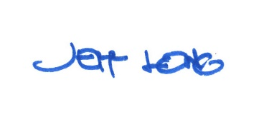

By:

Date of Meeting: November 19, 2018 Title: Historic Officer

